

**HealthTrust Europe LLP: ITT to establish a framework agreement for consultancy solutions and advisory services Contract Notice (FTS) Ref: 2023-041574**

**Technical Response – G4_Contract Monitoring_Ethical Healthcare Consulting**

G4: Please confirm you will attend regular contract review meetings with each Participating Authority (occasionally at the Participating Authorities premises, with no additional charge), as required, throughout the lifetime of the Framework Agreement. Please provide details of how you would use feedback from these meetings to improve/maintain service levels. As a minimum your response should detail:

• confirmation that regular contract review meetings will be attended, including on the Participating Authorities premises, where necessary;

• confirmation an agenda will be circulated prior to meetings;

• how meeting minutes and feedback will be recorded, circulated and maintained;

• how agreed resulting actions will be implemented; and

• how those actions will be monitored thereafter.

**EHC Response:**

**confirmation that regular contract review meetings will be attended, including on the Participating Authorities premises, where necessary;**

We confirm that we will attend regular contract review meetings with each client, including on-site visits at their premises as required, without additional charge.

Additionally, where appropriate, reports will be provided to support any contractual reviews and ensuring our clients are receiving the appropriate value for money.

Examples of where we have done this previously is with Buckinghamshire NHS Trust, where we supported their EPR programme. We embarked upon fortnightly Service and Contract management meetings with the Senior Leadership of the programme. This was a complex project with multiple workstreams where provided our client with regular reports to support the costs vs the actions undertaken within the project. The scope change was frequent, and staff moved across workstreams to support key gaps in the teams. Therefore, the meetings were frequent to ensure we remained within the appropriate boundaries, whilst also ensuring staff wellbeing.

Additionally, for Southern Counties Pathology post project support, the EHC team will support with any questions and ensure a full handover is completed with the client. EHC ensure our clients are left self-sufficient and have the necessary tools and knowledge to progress into business as usual.

We will often work with clients to maximise the value of their spend with us, by agreeing a step down in our support from hands on delivery to a light touch, senior advisory service. This enables clients to continue to realise the benefit of our associates extensive experience and expertise, whilst also building their own capability and capacity to deliver self-sufficiently.

**confirmation an agenda will be circulated prior to meetings;**

EHC confirm agenda will be circulated prior to contract review meetings. Prior to any contract review meetings, the following preparation is conducted by the EHC Delivery Manager:

* Review previous meeting minutes for continuity and follow-up on actions.
* Gather attendee-specific topics and concerns.
* Analyse stakeholder roles and tailor the agenda if required
* Draft a detailed agenda, including specific discussion items, responsible individuals, and time allotments.
* Distribute relevant documents and reports well before the meeting.
* Set clear objectives for what the meeting aims to achieve.
* Confirm participant availability in advance; reschedule if key attendees are unavailable.
* Plan for contingencies like key participant absence or IT issues.
* Engage in pre-meeting calls or emails with key participants to set expectations.
* Provide and distribute supporting documentation or ‘pre-reads’ in good time to allow full discussion at the meeting.
* In the event of virtual meetings, ensure attendees have access and understand how to use any IT tools which will be used to support the meeting, I.e Interactive boards, poll surveys, login details and links.

An example agenda we have done for a client is outlined in supporting documentation ***‘SD10 Example Board Agenda November 2023’.***

An additional illustration of an agenda is one prepared for Buckinghamshire Healthcare NHS Trust:

* Roles and time forecast
* Triaged wellbeing project related and governance issues
* Contract milestones
* Escalations
* AOB

This project necessitated a lighter touch approach; therefore, we used Microsoft PowerPoint to keep a track of the meeting. The slide deck also contained the supporting information from our systems, such as weekly run-rate, contract sections and deliverables, booked values and actions and notes from previous meetings. We have included this example to demonstrate how we are able to adapt to the specific needs of the projects that are involved in.

**how meeting minutes and feedback will be recorded, circulated and maintained;**

A EHC specific meeting tracker is utilised for workshops and engagement with the client.

The meeting tracker serves three purposes:

* Who EHC have engaged with to identify the key information within the final report
* Evidence to show key stakeholders were engaged as part of the outcome
* Evidence utilisation of time and effort as part of the project budget and deliverables
* With the permission of the client workshops should be recorded and only kept on EHC's SharePoint
* All meeting notes are uploaded onto teams or confluence depending on the platform you are using for the project
* Workshops and meetings are followed up with an email explaining the outputs and discussion points
* At the start of each meeting the purpose of the meeting is confirmed

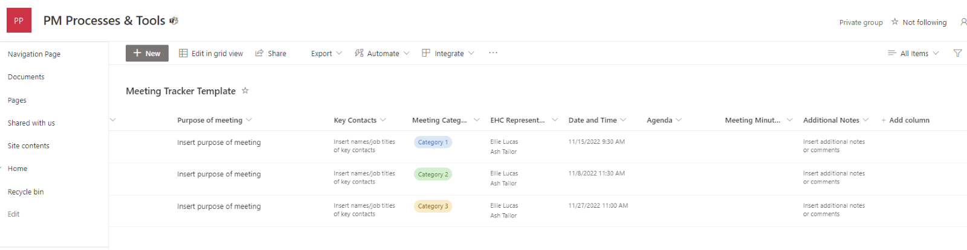

Meeting minutes and feedback are accurately recorded and promptly disseminated to all relevant parties, including those unable to attend. Clients will be able to provide feedback to the minutes to ensure information has been reflected accurately. In some cases, with agreement from the client, meetings can be recorded for note keeping or for those unable to attend.

These written meeting minute records will be shared through a dedicated Teams channel, providing a central repository for easy access and reference between EHC and the customer. Additionally, actions and updates will be tracked on a Jira Project Board or other platform the client specifies and accessible to all involved. The Delivery Manager is responsible for writing up the minutes, which are then emailed to attendees and added to the Teams channel. These minutes will then be incorporated into the next meeting's agenda for review and follow-up. The delivery manager will actively monitor the progress of actions, ensuring they are completed within set deadlines.

As part of our processes the following Project Governance file structure is used to organise information for ease of use/viewing by our customers:

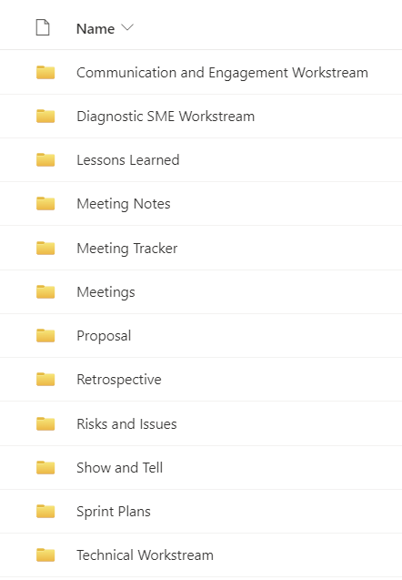

An example template of meeting minutes can be found under supporting documentation ***‘SD11 Example Board Meeting Minutes and Actions November 2023’.***

**how agreed resulting actions will be implemented; and**

Agreed actions arising from these meetings will be integrated into our project plan and assigned to the relevant stakeholder either internally or externally, by mutual agreement. A date will be agreed by when these actions should be completed by, monitored by the Delivery Manager.

This includes adjustments based on feedback regarding the service levels, budget management, and project milestones.

**how those actions will be monitored thereafter.**

Actions will be monitored through bi-weekly project board meetings, ensuring consistent oversight and alignment with the project's objectives and the project team's expectations. We use tools like highlight reports and budget review documents to track progress and adherence to the agreed actions. An example of an anonymised monthly highlight report:

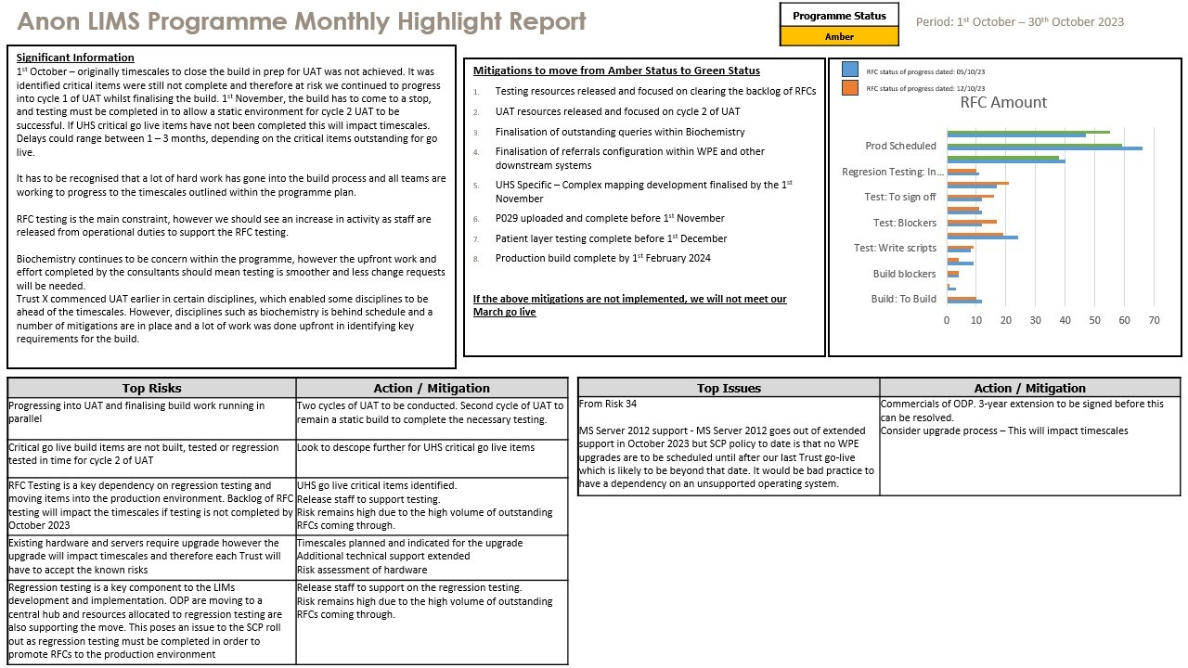

An example of a milestone tracker against budgets can be found under supporting documentation ***‘SD4 Milestone Tracker’***. This is also tracked internally in CMAP, our project resource software.

